**PIZZA SALES SQL QUERIES**

**KPI’s**

**1. Total Revenue:**

SELECT SUM(total_price) as Total_revenue

FROM pizza_sales

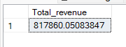

**2. Average Order Value**

SELECT SUM(total_price)/COUNT(DISTINCT(order_id)) as avg_order_value

FROM pizza_sales



**3. Total Pizzas Sold**

SELECT SUM(quantity) as total_sold

FROM pizza_sales



**4. Total Orders**

SELECT COUNT(DISTINCT(order_id)) as order_count

FROM pizza_sales



**5. Average Pizzas Per Order**

SELECT CAST(CAST(SUM(quantity)AS DECIMAL (10,2)) / CAST(COUNT(DISTINCT(order_id))AS DECIMAL (10,2)) AS DECIMAL(10,2)) as avg_pizza_per_order

FROM pizza_sales



**Daily Trend For Total Orders**

SELECT DATENAME(DW,order_date) as Day_of_week , COUNT(DISTINCT(order_id)) as no_of_orders

FROM pizza_sales

GROUP BY DATENAME(DW,order_date)

***Output:***

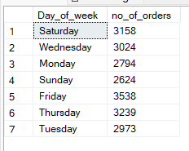

**Monthly Trend for Orders**

SELECT DATENAME(MONTH,order_date) as name_of_month , COUNT(DISTINCT(order_id)) as no_of_orders

FROM pizza_sales

GROUP BY DATENAME(MONTH,order_date)

***Output***

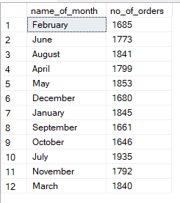

**Percent of Sales by Pizza Category**

SELECT pizza_category, CAST(SUM(total_price) as DECIMAL(10,2)) as total_revenue ,

CAST((SUM(total_price) / (SELECT SUM(total_price) FROM pizza_sales)) * 100 AS DECIMAL (10,2)) as Percent_of_sales

FROM pizza_sales

GROUP BY pizza_category

***Output***

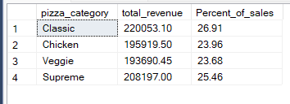

**Percent of Sales by Pizza Size**

SELECT pizza_size, CAST(SUM(total_price) as DECIMAL(10,2)) as total_revenue ,

CAST((SUM(total_price) / (SELECT SUM(total_price) FROM pizza_sales))

* 100 AS DECIMAL (10,2)) as Percent_of_sales

FROM pizza_sales

GROUP BY pizza_size

ORDER BY Percent_of_sales DESC

***Output***

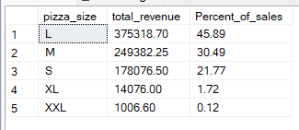

**Total Pizzas Sold by Pizza Category**

SELECT pizza_category,SUM(quantity) as Total_pizzas_sold

FROM pizza_sales

GROUP BY pizza_category

ORDER BY Total_pizzas_sold DESC

***Output***

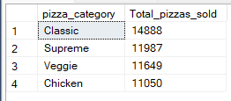

**Top 5 Pizzas by Revenue**

SELECT TOP 5 pizza_name,SUM(total_price) as revenue_generated

FROM pizza_sales

GROUP BY pizza_name

ORDER BY revenue_generated DESC

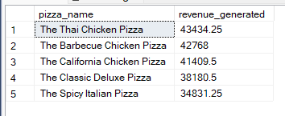

**Bottom 5 Pizzas by Revenue**

SELECT TOP 5 pizza_name,SUM(total_price) as revenue_generated

FROM pizza_sales

GROUP BY pizza_name

ORDER BY revenue_generated ASC

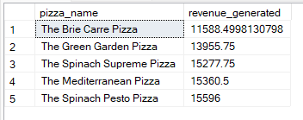

**Top 5 Pizzas by Quantity**

SELECT TOP 5 pizza_name,SUM(quantity) as quantity_ordered

FROM pizza_sales

GROUP BY pizza_name

ORDER BY quantity_ordered DESC

***Output***

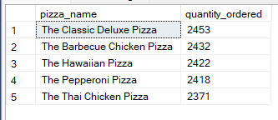

**Bottom 5 Pizzas by Quantity**

SELECT TOP 5 pizza_name,SUM(quantity) as quantity_ordered

FROM pizza_sales

GROUP BY pizza_name

ORDER BY quantity_ordered ASC

***Output***

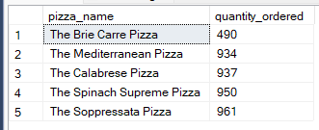

**Top 5 Pizzas by Total Orders**

SELECT TOP 5 pizza_name,COUNT(DISTINCT order_id) as Total_orders

FROM pizza_sales

GROUP BY pizza_name

ORDER BY Total_orders DESC

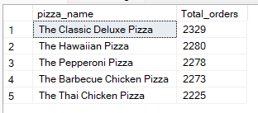

**Bottom 5 Pizzas by Total Orders**

SELECT TOP 5 pizza_name,COUNT(DISTINCT order_id) as Total_orders

FROM pizza_sales

GROUP BY pizza_name

ORDER BY Total_orders ASC

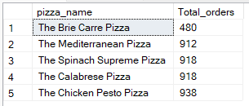

***NOTE***

If you want to apply the pizza_category or pizza_size filters to the above queries you can use WHERE clause. Example :-

SELECT TOP 5 pizza_name,COUNT(DISTINCT order_id) as Total_orders, pizza_category

FROM pizza_sales

WHERE pizza_category = 'Classic'

GROUP BY pizza_name,pizza_category

ORDER BY Total_orders ASC